TASK:
The server proudly announces its identity in every response. Look closely; you might find something unusual.
Solution:
# nmap -A -p- target.ine.local
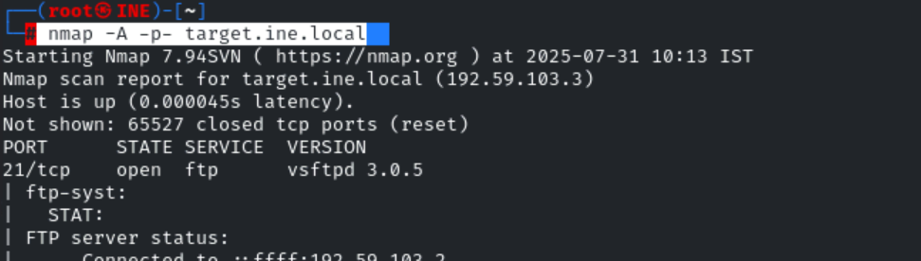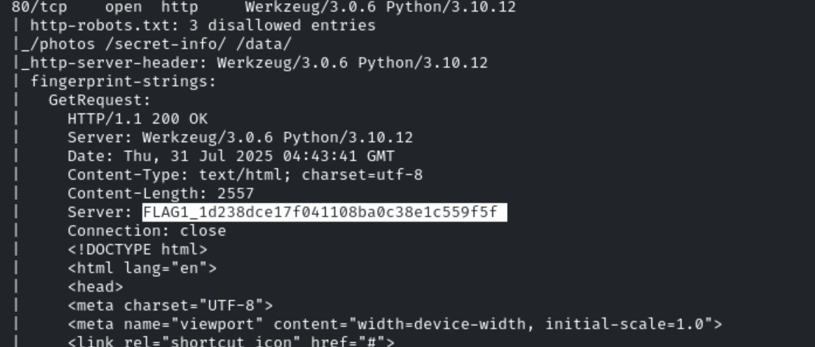

Answer:
FLAG1_1d238dce17f041108ba0c38e1c559f5f
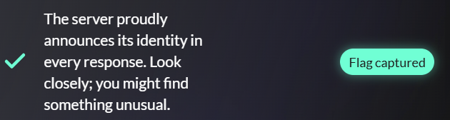

TASK:
The gatekeeper’s instructions often reveal what should remain unseen. Don’t forget to read between the lines.
Solution:
Naturally, I would go the webpage since ports 80 or 443 were open and look for basic files such as robots.txt, sitemap.xml, security.txt, etc. And if you notice in the above nmap result there are some directories listed which aren’t allowed little bit suspicious …… I mean it scratch that part of my brain.

http://target.ine.local/robots.txt
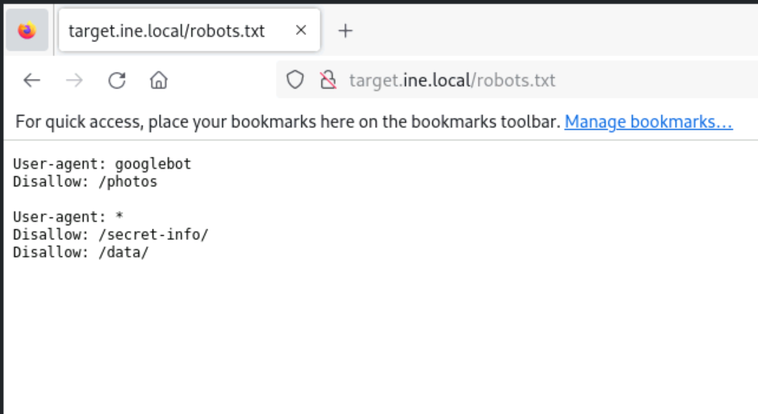

So I went to each path specified but apart from secret-info, the other two paths returned 404 errors. And I was stuck on this one for a while I was wondering what to do. I checked the cookies, network tabs, request responses, etc., but found nothing then I notice the file type was a document, so I appended flag.txt to the path and boom got the flag.
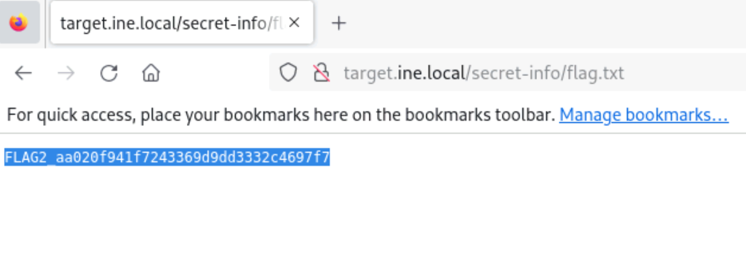
Answer:
FLAG2_aa020f941f7243369d9dd3332c4697f7

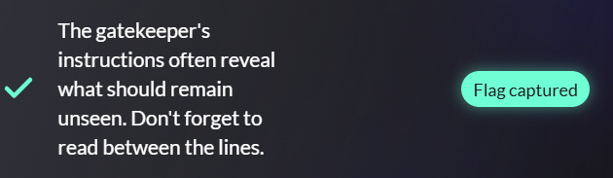
TASK:
Anonymous access sometimes leads to forgotten treasures. Connect and explore the directory; you might stumble upon something valuable.

Solution:
Anonymous hmmm, well there is only on protocol that allows anonymous that is FTP. And if you would carefully look at the nmap result of ftp there is anonymous access allowed.
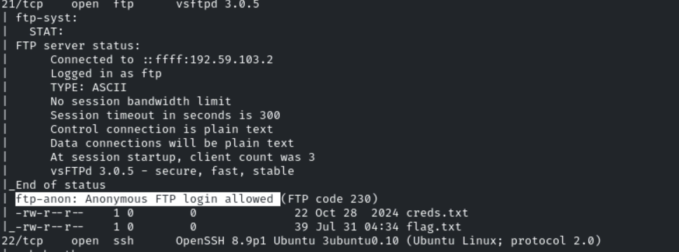
To access:
ftp anonymous@192.59.103.3/

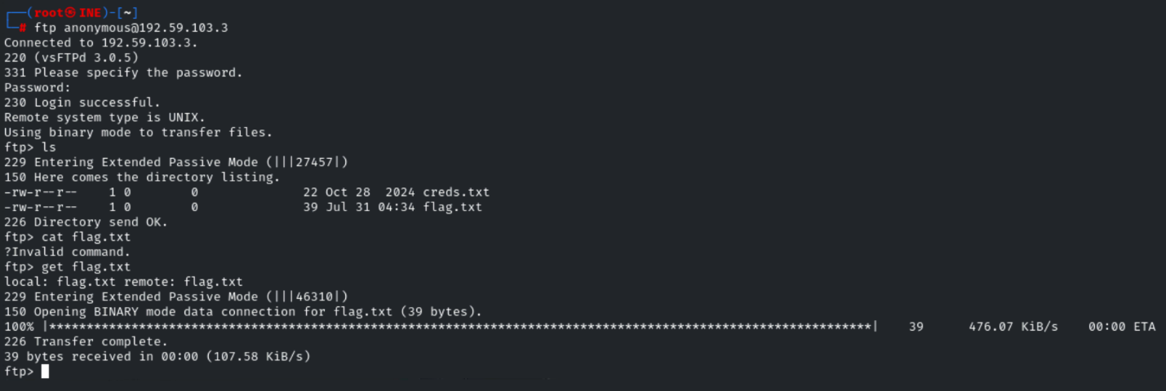
Use the get to download the file.
And then cat it.
cat flag.txt
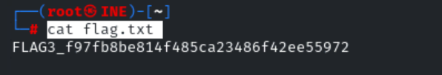
Answer:
FLAG3_f97fb8be814f485ca23486f42ee55972
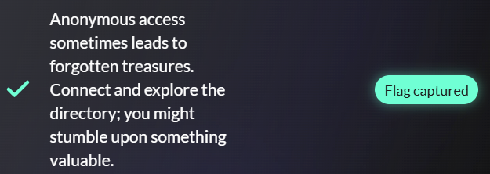

TASK:
A well-named database can be quite revealing. Peek at the configurations to discover the hidden treasure.
Solution:
ftp anonomus@ip-address
get the creds.txt file
it contain the credentials to the mysql database :
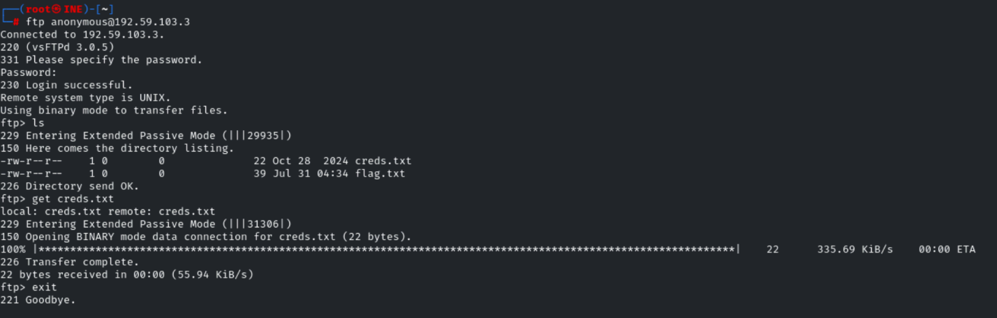
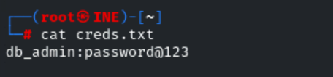
Login to the database:

mysql -h <target> -u <username> -p
mysql -h 192.59.103.3 -u db_admin -p
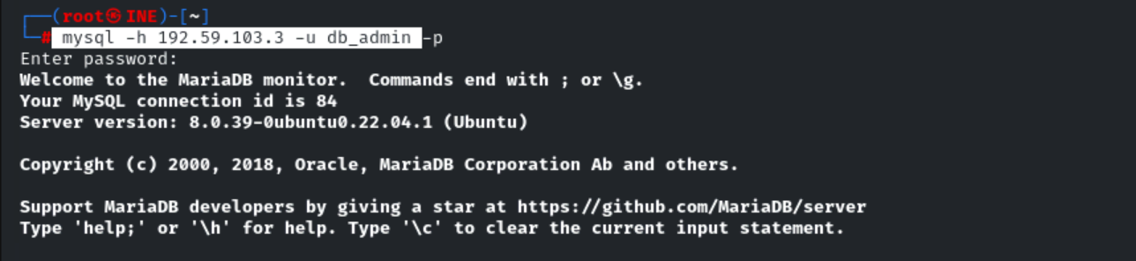
show databases; //to list databases
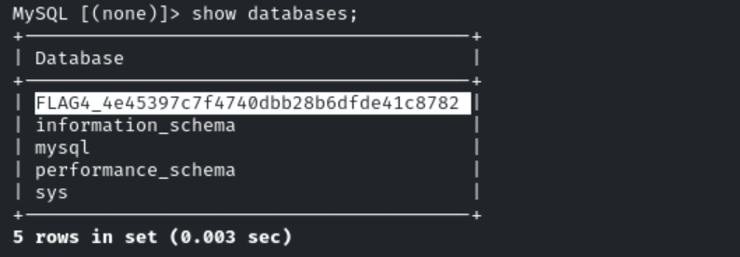

Answer:
FLAG4_4e45397c7f4740dbb28b6dfde41c8782
